本文档是海南版预录入系统接口对接的使用方法。

目录
1. 保税订单添加接口（做此业务请先注册并完成商品库存录入） 2
2. 订单申报及运单查询接口 3
3. 接口可视化swagger界面 4

保税订单添加接口（做此业务请先注册并完成商品库存录入）
注：apptoken、appkey值需要注册预录入系统后在公共管理-企业账户管理中获取
注册地址：http://47.112.3.12:8089/pre/ （请先联系当地业务负责人）
（注册后填写基本信息需要管理员审核）
childid值取企业账户管理中企业编号值
storeid值填J

http method | POST
地址 | http://47.112.3.12:8288/ibOrder?apptoken=2&appkey=2
Post方式提交json格式参数 | {  "acturalpaid": 0,  "batchnumbers": "string",  "buyeridnumber": "string",  "buyername": "string",  "buyerregno": "string",  "childid": "string",  "consignee": "string",  "consigneeaddress": "string",  "consigneecity": "string",  "consigneecompany": "string",  "consigneeemail": "string",  "consigneeidcard": "string",  "consigneeprovince": "string",  "consigneestreet": "string",  "consigneetelephone": "string",  "discount": 0,  "ebpcode": "string",  "ebpname": "string",  "expressid": "string",  "freight": 0,  "items": [  {  "defaultcode": "string",  "price": 0,  "qty": 0,  "sku": "string"  }  ],  "note": "string",  "orderno": "string",  "paycode": "string",  "payname": "string",  "paytransactionid": "string",  "purchasertelephone": "string",  "storeid": "string",  "taxtotal": 0  }
返回格式 | { "result": "99", "desc": "认证失败" }或者{ "result": "00", "desc": "成功" }.....
备注 | 返回的desc内容看具体情况，请自测

订单申报及运单查询接口
注：密钥获取方式同上
http method | Get
地址 | http://47.112.3.12:8288/order?orderno=2&apptoken=2&appkey=2
返回参数 | {  "result": "00",  "desc": "",  "liststatus": "800",  "liststatusdesc": "放行",  "orderstatus": "2",  "orderstatusdesc": "出库",  "shippingdate": "2020-06-16 14:10:37",  "weight": "1.24",  "logisticsno": "9786243190998",  "orderhistory": "[{"id":{"declareType":"1","guid":"CEB311_HNZB_SLYC_20200616174889_0001","guidReturn":"CEB311_HNZB_SLYC_20200616174889_0001","returnType":"HG","returninfo":"新增申报成功[CEB311_HNZB_SLYC_20200616174889_0001]","returnstatus":"2","returntime":"20200616093027"}}]",  "inventoryhistory": "[{"id":{"declareType":"4","guid":"CEB621_HNZB_SLYC_20200615496066_0001","guidReturn":"CEB621_HNZB_SLYC_20200615496066_0001","returnType":"HG","returninfo":"清单新增申报成功[电商企业编码：4601630005订单编号：E202006151645290231000011210HC]","returnstatus":"2","returntime":"20200616093423"}},{"id":{"declareType":"4","guid":"CEB621_HNZB_SLYC_20200615496066_0001","guidReturn":"7329ccf7-6cf1-4cc6-a131-98c33ebed9ed","returnType":"HG","returninfo":"[Code:1200;Desc:待人工审核]","returnstatus":"300","returntime":"20200616093407"}},{"id":{"declareType":"4","guid":"CEB621_HNZB_SLYC_20200615496066_0001","guidReturn":"2057b27c-a0fe-4f33-9d96-404de7cfa5f9","returnType":"HG","returninfo":"[Code:2600;Desc:放行]","returnstatus":"800","returntime":"20200616103956"}},{"id":{"declareType":"4","guid":"CEB621_HNZB_SLYC_20200615496066_0001","guidReturn":"63d19481-ad0e-4aae-a428-5807d0f8bcd2","returnType":"HG","returninfo":"[Code:1800;Desc:逻辑校验通过]","returnstatus":"120","returntime":"20200616093505"}}]"  }
备注 | 错误示例请自己测试

接口可视化swagger界面
保税订单添加接口可视化swagger地址：
http://47.112.3.12:8288/swagger-ui.html#!/order-controller/neWinsertIbOrderUsingPOST
字段注释：optional 字段为非必填字段。
电子邮箱可以填写固定值。

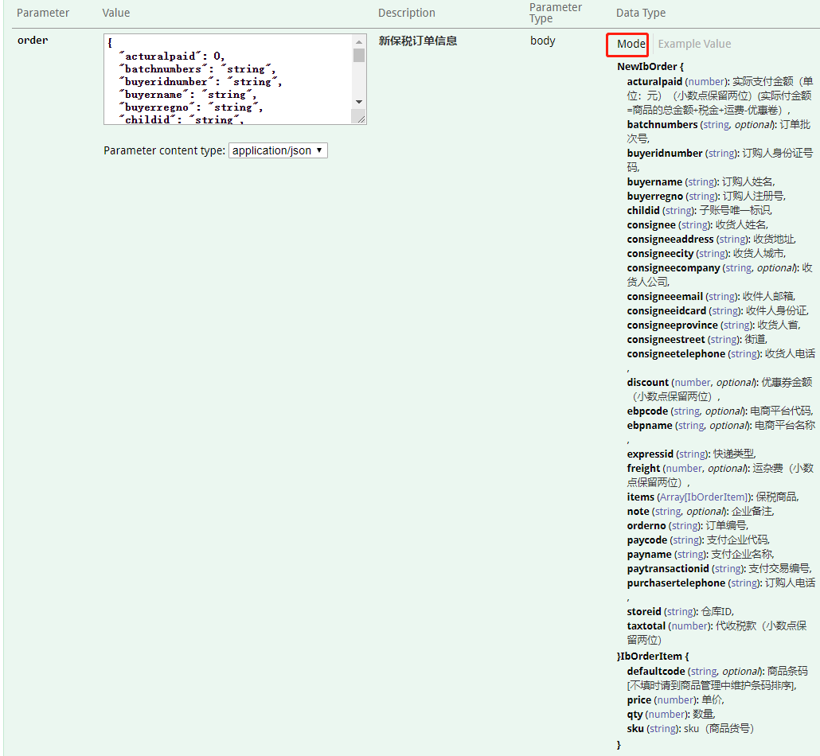订单申报及运单查询接口可视化swagger地址：
http://47.112.3.12:8288/swagger-ui.html#!/order-controller/getOrderUsingGET
